ENCAPSULATION
*Binding or wrapping the data and code into in a single unit is called encapsulation.
*class is a example of encapsulation.
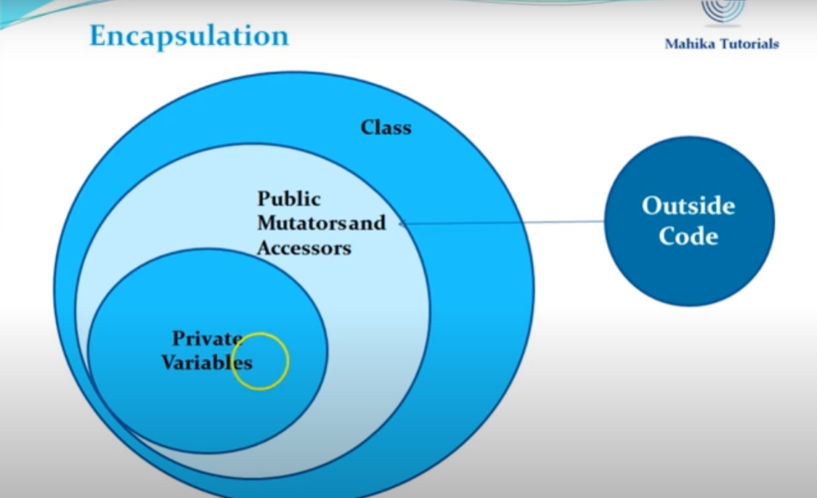

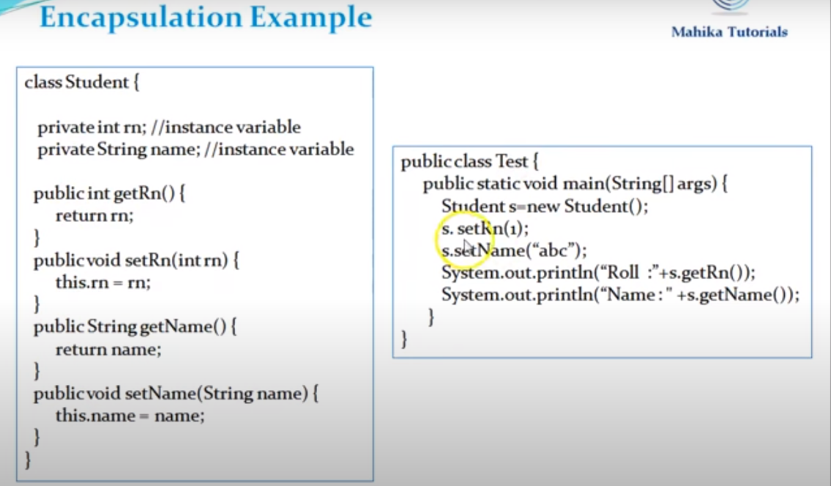

We can access data by set and get method from the outside.

Abstraction
We know the functionality of ATM and SMS but we don’t know the how they work.
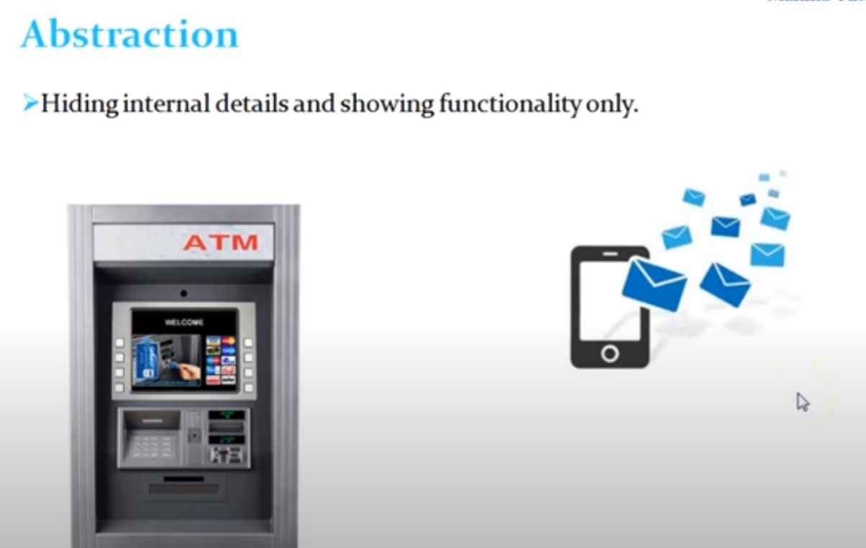
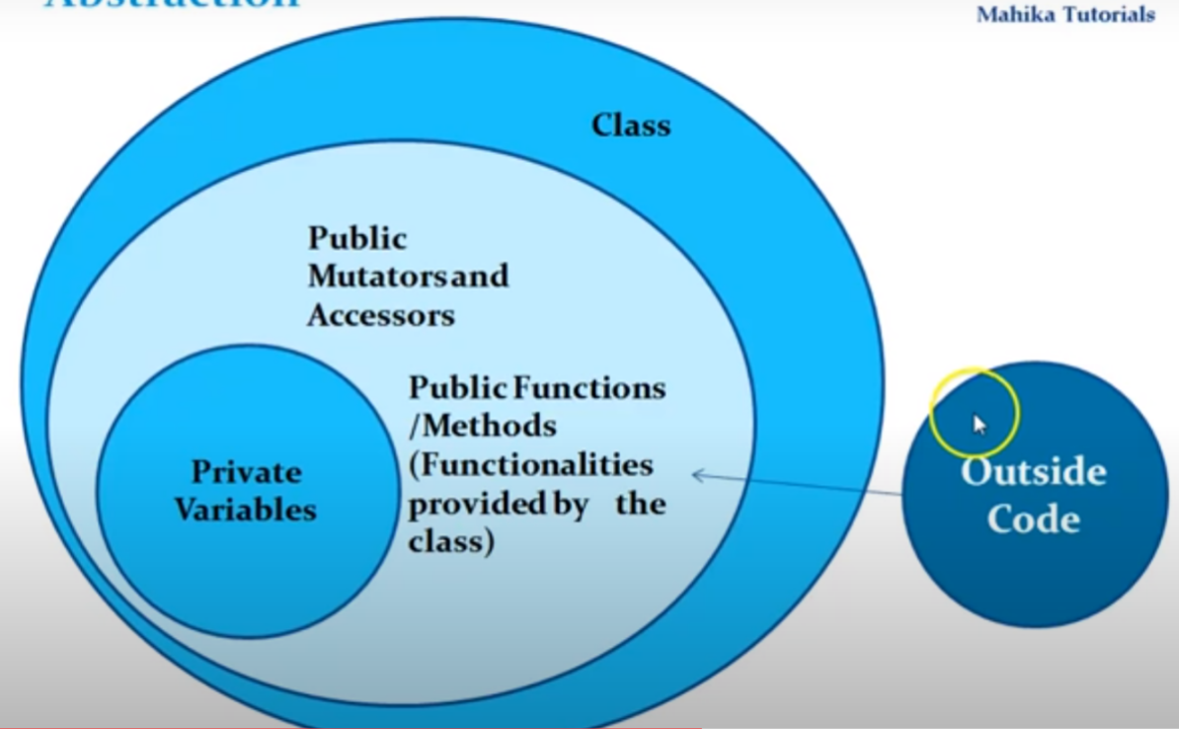
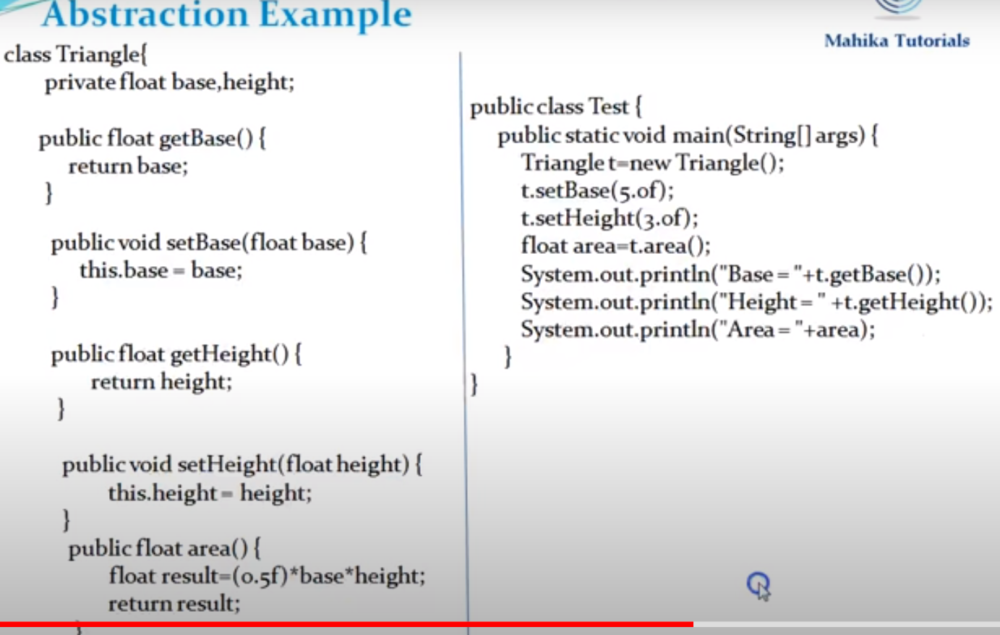

We know the base and height ,but we don’t know how area is calculated ,this is called abstraction.

